|  |
| --- |
| 3D Pong Design Document |
| Seamus O’ Neill: C00157683 |
| 1st September 2014 |
|  |



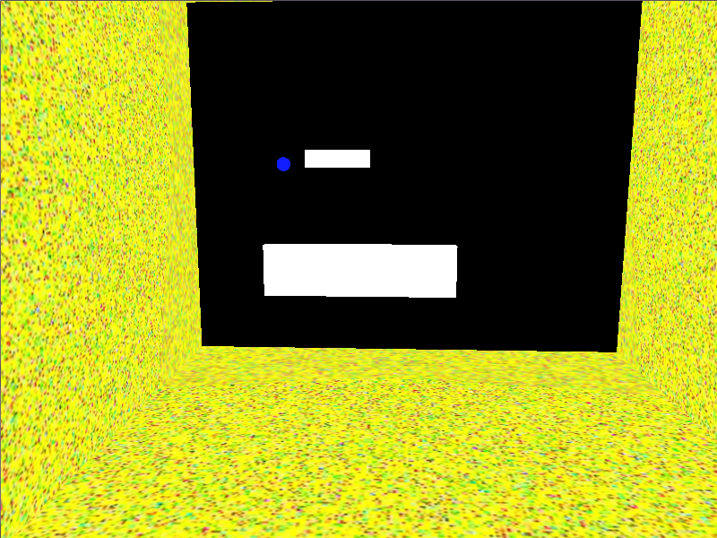

**Table Of Contents**

Functionality Planned for final demonstration…………………………………………………2

Game Mechanics……………………………………………………………………………………………..3

Space.……………………………….………………………………………..……………………………………..3

Objects …………………………………………………………………………………..………………………….3

Actions……………………………………………………………………..………………………………………..3

Rules………………………………………….………………………………………..…………………………….4

Skills……………………………………………..………………………………………..…………………………4

Chance…………………………..………………………………………..……….………………………………..4

Level Requirements

Level diagram….……………………………..………………..………..………………………………………..5

Asset Revelation Schedule…………………………………..……………………………………………………5

User Interface………………………………..……………...………………………………………..………6

**Functionality Planned for Final Demonstration**

AI

A basic opponent AI is needed to be present in order for the game to continue past the opening volley. The player AI will be able to see the ball and move to a position to deflect it.

Collision

It is necessary that the ball collides with the paddles and the wall in order to keep the game going. It will also need to bounce off these objects in a reasonable manner. Also the paddles will have to collide with the walls in order to be prevented leaving the box.

Ball

A consistently moving ball.

Sound

There should be a sound effect to indicate if the ball collided with a paddle or the wall or if the player or opponent scored.

Controls

The player should be able to move their paddle to block the ball

GUI

The game score should keep track of the score and be visible to the player.

**Game Mechanics**

Space

Despite the game being called 3D pong, the player is only able to move in 2 dimensions. The player can move along the x-axis or along the y-axis but not along the z-axis which only the ball can travel along.

The player is within a rectangular box with two open ends. The player s at one of these openings and the enemy is at the other. The ball travels in the middle of the player and the opponent and has the ability to travel past them outside of the box.

The camera remains behind the player at all times and they can rotate it using the mouse to see the field from other angles.

Due to not being able to travel on the z-axis the player is stuck inside the box, similar to traditional ‘Pong’

Objects

* Paddle
  + A movable rectangular object.
  + Inherits from the class MovingObject.
  + Both the player and the opponent are this type of object.
  + Solid, cannot move through walls.
  + Can only move along the x and y axes.
  + Longer on the horizontal plane than on the vertical plane, very thin on the z plane.
  + Is not affected by gravity
* Ball
  + Moves with a set velocity on the x,y and z planes.
  + Inherits from the class MovingObject
  + Bounces off any other object it collides with.
  + Resets to the middle of the box if it goes outside the box but keeps it’s velocity,
  + Spherical in shape.
  + Only changes velocity on the z axis if it hits a paddle.
  + Is a static object.
* Wall
  + Solid rectangular object.
  + Is instance of the class BaseObject.
  + Is not affected by collisions.
  + Object which keeps paddles and ball in the field.
  + Remains stationary throughout the game.

Actions

The player can move along the x and y axes at a constant velocity.

The player will need to deflect the ball as it comes towards their end of the field.

The player will need to aim the ball to try beat the opponent.

Rules

The player has to stay within the box, it is impossible for them to leave.

If the ball comes in contact with the player it bounces off them in the opposite direction.

If the ball makes it past the player out of the box the opponent scores a point and vice versa.

There is no score limit, the player plays until they get bored.

The player has limited control of the camera

Skills

The game requires only real skills; there is no levelling up or ranking in the game.

The player needs to have good spatial awareness in order to be aware of the position of the ball and the paddle and their proximity to one another.

The player needs good reflexes in order to move towards the ball before it’s too late.

The player will need minimum familiarity with game controls in order to play seamlessly.

Chance

The element of chance in the game is the destination of the ball. Although the physics is predetermined there is still a fair amount of risk as to guessing where the ball is going to go so that the player can move into position. If the player makes a mistake it might not be possible for them to reach the ball before it leaves the field.

**Level Requirements**

Level Diagram

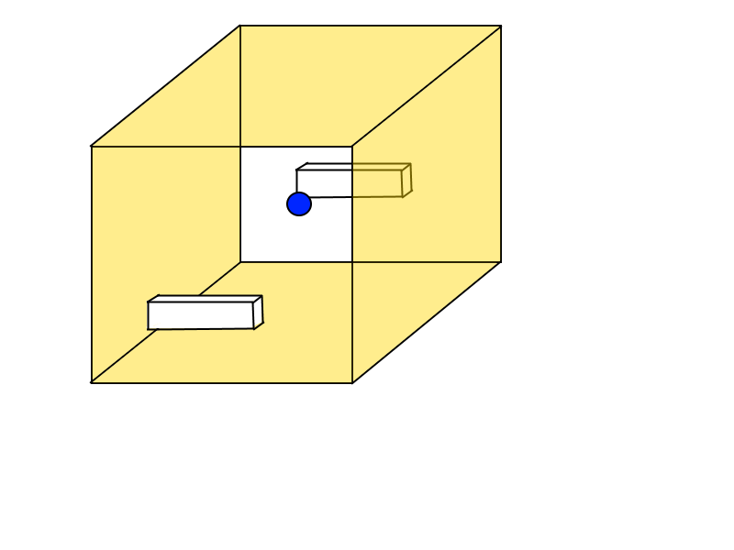

As you can see from above the ball travels between the players within the box and the player can only travel within their goal.

Asset Revelation schedule

There is only one level and all assets are immediately available. No schedule is applicable.

**User Interface**

The user interface displays the score at the top left hand side of the screen. It has a row for player score and a row for opponent score.